**Topic: Box plots**

Time: 45 mins Marks: /45 marks

**No calculator allowed**



**Question One: [8, 3: 11 marks]**

Consider the following data:

|  |  |
| --- | --- |
| Data 1 | Data 2 |
| 1 | 1 |
| 2 | 1 |
| 2 | 1 |
| 3 | 4 |
| 5 | 6 |
| 6 | 7 |
| 6 | 8 |
| 6 | 8 |
| 8 | 9 |
| 9 | 10 |
| 10 | 10 |

a) Draw a box-plot to represent each set of data.

b) Compare the two data sets using statistical measures in your comparison.

**Question Two: [4, 4: 8 marks]**

Draw a possible histogram to match each of the following box-plots with 10 data points.







**Question Three: [6 marks]**

A JB Hi Fi store are analysing their daily CD sales over the past month and the following findings have been noted.

The lowest number of sales per day during the last month is 40 sales.

The middle 50% of sales is between 75 and 110 sales.

Half of the time the store sold more than 95 CDs per day.

On one day the number of CD sales could *just* be considered an outlier and it was their maximum number of sales for a day.

Draw a box-plot, clearly labeling the 5 key statistical data points, to match this description.

**Question Four: [1, 1, 1, 1, 1, 3: 8 marks]**

Amy is comparing the average daily temperatures of three European cities for the month of June. She summarises her findings in the box plot below.

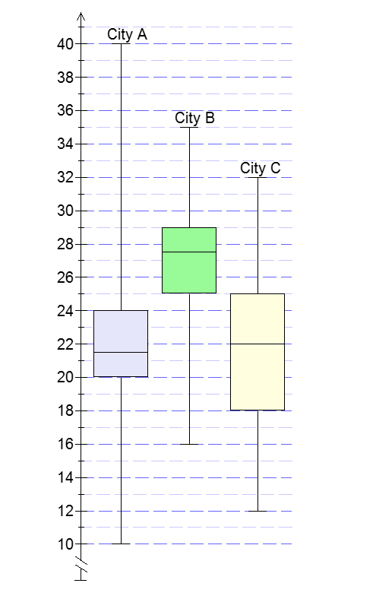

a) Which city recorded the highest average daily temperature during the month of June?

b) Which city recorded the highest median for the average daily temperature during the month of June?

c) Which city had the smallest interquartile range for the average daily temperatures recorded?

d) In City A, what percentage of the days in June was the average daily temperature above 20 degrees?

e) In City B 75% of the days recorded an average daily temperature higher than 75% of the days in City C. What is this average daily temperature?

f) If Amy prefers higher temperatures but also enjoys consistency in temperatures, which city should she choose to visit? Provide statistical reasoning to justify your solution.

**Question Five: [4, 4, 4: 12 marks]**

For each of the following sets of data there are four pieces of data missing. Use the box-plots to complete the sets of data.

a) 8, 9, 12, 14, 18, 20, 25



b) Data: 6, 6, 10, 20



c) 2, 2, 4, 4

**Topic: Box plots SOLUTIONS**

Time: 45 mins Marks: /45 marks

**No calculator allowed**



**Question One: [8, 3: 11 marks]**

Consider the following data:

|  |  |
| --- | --- |
| Data 1 | Data 2 |
| 1 | 1 |
| 2 | 1 |
| 2 | 1 |
| 3 | 4 |
| 5 | 6 |
| 6 | 7 |
| 6 | 8 |
| 6 | 8 |
| 8 | 9 |
| 9 | 10 |
| 10 | 10 |

a) Draw a box-plot to represent each set of data.

Max/min Median Q1 Q3 1 mark each for each box plot

b) Compare the two data sets using statistical measures in your comparison.

* Both data sets have the same range.
* Data set 2 has a larger IQR.
* Data set 2 has a larger median

1 mark per comment

**Question Two: [4, 4: 8 marks]**

Draw a possible histogram to match each of the following box-plots with 10 data points.











**Question Three: [6 marks]**

A JB Hi Fi store are analysing their daily CD sales over the past month and the following findings have been noted.

The lowest number of sales per day during the last month is 40 sales.

The middle 50% of sales is between 75 and 110 sales.

Half of the time the store sold more than 95 CDs per day.

On one day the number of CD sales could *just* be considered an outlier and it was their maximum number of sales for a day.

Draw a box-plot, clearly labeling the 5 key statistical data points, to match this description.







**Question Four: [1, 1, 1, 1, 1, 3: 8 marks]**

Amy is comparing the average daily temperatures of three European cities for the month of June. She summarises her findings in the box plot below.



a) Which city recorded the highest average daily temperature during the month of June?

A

b) Which city recorded the highest median for the average daily temperature during the month of June?

B

c) Which city had the smallest interquartile range for the average daily temperatures recorded?

A and B

d) In City A, what percentage of the days in June was the average daily temperature above 20 degrees?

75%

e) In City B 75% of the days recorded an average daily temperature higher than 75% of the days in City C. What is this average daily temperature?

25%

f) If Amy prefers higher temperatures but also enjoys consistency in temperatures, which city should she choose to visit? Provide statistical reasoning to justify your solution.



B. Smaller range and smaller IQR indicating consistency in temperatures. B also has a higher median indicating higher temperatures.

**Question Five: [4, 4, 4: 12 marks]**

For each of the following sets of data there are four pieces of data missing. Use the box-plots to complete the sets of data.

a) 8, 9, 12, 14, 18, 20, 25



b) Data: 6, 6, 10, 20





c) 2, 2, 4, 4

